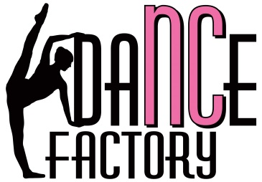
Policy & Procedures
Studio Rules:
- All students must follow the NCDF dress code policy (See Below)
- There will be no food or gum permitted in the dance room
- All young dancers must be escorted to and from the front door of the studio
- Dancers should arrive 5 minutes prior to the beginning of class and be picked up promptly after class
- Parents/guardians must remain outside of the dance room during class time unless otherwise requested by the dance teacher
- Continued disruptive behavior by a student (following a warning) may result in a time-out during class time.

Dress Code:
All Styles:
- Hair worn out of face
- No jewelry (small stud earrings will be allowed)
Ballet:
- Leotard (any color)
- Pink tights
- Pink leather full-sole ballet shoes (or pointe shoes if taking pointe class)
- Ballet skirts are optional
Tap:
- A top that is easy to move in
- Shorts, capris, or leggings
- Black tap shoes- lace-up, buckle, and ribbon tie (for young children) are all acceptable
Jazz:
- A top that is easy to move in
- Shorts, capris, or leggings
- Black split-sole slip on jazz shoes

Registration: A non-refundable fee of $20 per student is required annually at the time of registration.
Tuition: Tuition is divided into 10 equal installments. We will be operating on a 10-month season (late August- late May) allowing an average of 3.5 classes per month (taking into consideration days off for holidays). Therefore, our tuition fee is the following:
- Each 60-minute class: $42 per month
- Each 45-minute class: $35 per month
There is a 10% discount for families registered for 3 or more classes per week.
Tuition is due before or at the first class of the month and can be paid by check, cash, or through the NCDF website via PayPal, debit card, or credit card. Anyone wishing to pay the year’s tuition in full by the student’s first class will receive a 10% discount.
Kinder Dance and adult classes are the only classes that may be paid on a per class basis:
- Kinder Dance: $10 per class
- Adult classes: $12 per class

Cancelled Classes: If the studio must cancel classes due to extreme weather or other events beyond our control, make-up classes will be offered. In regards to closings due to weather, NCDF will follow the Wake County Public School System.
Referral Rewards: We appreciate our dance families spreading the word about NCDF. To show it, we have improved our referral rewards program. For any new dancer that registers for classes upon your referral, you will receive one class’ tuition free for a month! If a referral results in a student signing up for one of our dance camps, you will receive a $40 NCDF gift certificate to use towards our camps, classes, or recital expenses. Best of all, these referral rewards are unlimited!
Recital Information: Performing is an exciting part of being a dancer. The preparation and performance experience helps to build self-confidence, teamwork, and a sense of accomplishment in our young dancers. NC Dance Factory will hold two performances (one in winter and one in spring) to allow our students the opportunity to show their friends and family all the skills they have learned and improved upon throughout the year. Performances do involve some extra expenses. Both recitals will involve additional expenses of the dancer’s costume and admission tickets for any friends and family wishing to attend. Extra-curricular activities for children can become expensive, but we strive to keep these recital expenses as minimal as possible. More recital details will be given to parents further into the season.
I have read and agree to the NC Dance Factory Policies and Procedures stated above

___________________________ __________________________ ___________
Printed Name Signature Date

